 | Bill Payment  System  Technical Design Document  1.0
 | Prepared By / Last Updated By | Reviewed By | Approved By
Name | Anuj Saraogi | Vansh Madan | Ashu Jauhari
Role | Team Member | Team Member | Scrum Master
Signature | Anuj Saraogi | Vansh Madan | Ashu Jauhari
Date | 08-Apr-2019 | 08-Apr-2019 | 08-Apr-2019

Table of Contents

1.0 Introduction 4
1.1 Purpose of this document 4
1.2 Scope 4
1.3 Intended Audience 4
1.4 Definition & Acronyms 4
2.0 Assumptions, Dependencies and Risks 5
2.1 Assumptions: 5
2.2 Dependencies: 5
3.0 Schematic Diagram 5
4.0 Use Case Realization 6
4.1.1 User Registration 6
a. Functional Requirement 6
b. UI Validations 6
c. UI Controls 7
d. UI Methods Definition 7
e. UI Design 8
4.1.2 User Credential Authentication 8
a. Functional Requirement 8
b. UI Validations 8
c. UI Controls 8
d. UI Methods Definition 9
e. UI Design 9
4.1.3 Vendor Registration 9
a. Functional Requirement 9
b. UI Validations 9
c. UI Controls 10
d. UI Methods Definition 11
e. UI Design 11
4.1.4 Record Bill 11
a. Functional Requirement 11
b. UI Validations 12
c. UI Methods Definition 12
d. UI Design 12
4.1.5 Pending Bills 13
a. Functional Requirement 13
b. UI Methods Definition 13
c. UI Design 14
4.1.6 Pay Bills 14
a. Functional Requirement 14
b. UI Controls 14
c. UI Methods Definition 15
d. UI Design 15
5.0 Database Design 16
5.1 Data Model 16
The following is a schematic view of the database design 16
5.2 Tables Structure 16
6.0 Change Log 18

Introduction

Purpose of this document
The purpose of the detail design document is to define the detailed design for all the components of Bill Payment System that are specified in the Business Requirement/Use case document. All the low level components, interfaces and integrations are detailed out in this document.

Scope
This sub-section shall state the scope of this detailed design document
• Create and maintain user information.
• Create and maintain vendor information.
• Create and maintain bill information.

Intended Audience
The intended audience for this document are
- Developers, testers, other associates in the project
- Technical lead, Scrum Master
- Product Owner

Definition & Acronyms
Acronyms | Definitions
BPP | Bill Payment Portal

Assumptions, Dependencies and Risks

Assumptions:
- Once the application is built the Bill Payment System will manually load the user list into the system.
- There will be no concurrent users for the application. The User profile will be maintained by the User.
- Any changes to the design mentioned in the BRD would be taken as a Change Request

Dependencies:
- Availability of database design characteristics & access shall be defined by the
- Resource availability throughout each of the sprint

Schematic Diagram
A schematic, or schematic diagram, is a representation of the elements of a system using abstract, graphic symbols rather than realistic pictures. It gives an overview of overall system
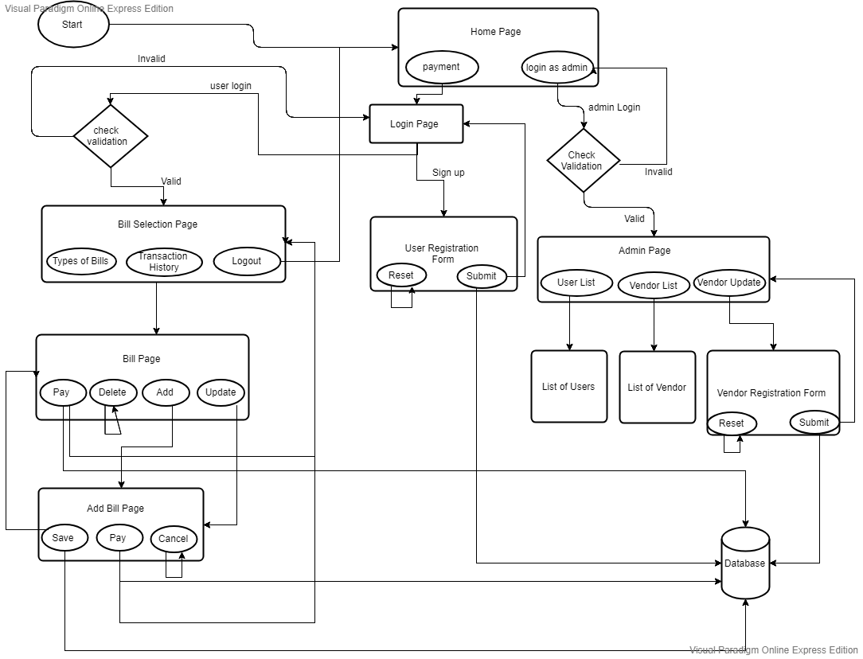
BPS_Pic-11.0 Overview of Bill Payment System

Use Case Realization

User Registration

Functional Requirement
. This use case deals with the capture of user details. The ‘user’ here shall be the operator of the system and will be keying in the user details.

UI Validations
- All fields are mandatory.
- Password should have maximum 15 alphanumeric, space & can contain special characters (ex.!,@,#,%,*,& etc.)
- The Email ID format must be checked.
- Phone Number must be of 10 digits’ length.
- Age should be 2 digit numeric value.
- First Name, Last Name should contain only alphabets.
- Gender should be chosen from the dropdown options.
- PAN, Aadhar Number, UserId should be alphanumeric maximum.

UI Controls
# | UI Component | Type | Name | Details
1 | First Name | Text Field | FirstName | To enter first name of user
2 | Last Name | Text Field | LastName | To enter last name of user
3 | Adhaar Number | Text Field | Adhaar | To enter Adhaar card number of user
4 | Pan Number | Text Field | Pan | To enter Pan card number of user
5 | Age | Text Field | Age | To enter age of user
6 | Gender | Text Field | Gender | To enter gender of user
7 | Contact Number | Text Field | ContactNo | To enter contact number of user
8 | UserId | Text Field | Username | To enter username of bill payment system
9 | Email Id | Text Field | EmailId | To enter email id user currently using
10 | Password | Password Field | Password | To enter password kept for bill payment system

UI Methods Definition
Method Name | Parameter | Details
Registor_button | Object User | Allows the user to register his details
Reset_button | None | Allows the user to clear the fields

UI Design

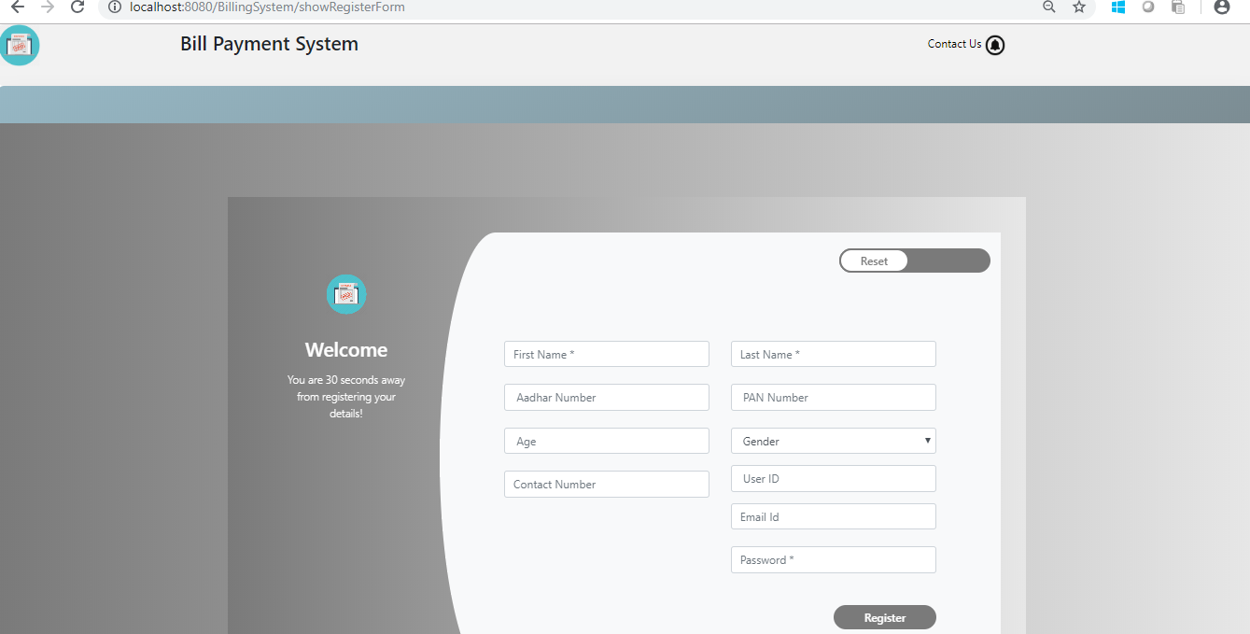
BPS_Pic-3.0 Registration Form of User
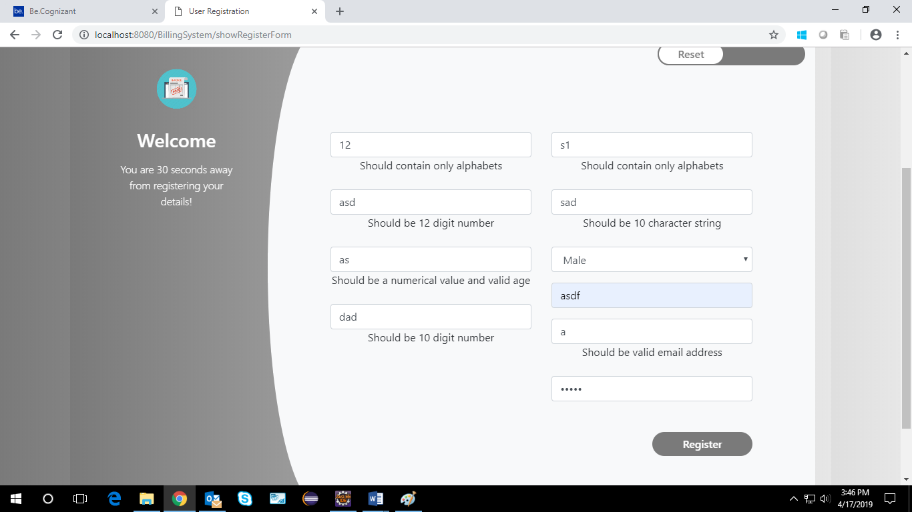
BPS_Pic-17.0 Registration Validation Form of User

User Credential Authentication

Functional Requirement
. Login Page checks the authentication of the user and based on his role, directs the user to the respective page. User will be provided with links to select the respective bill type and the will be allowed to see pending bills, can pay those bills and add new bills.

UI Validations
- User Id and Password fields are mandatory.
- Invalid User Id and / or password should not allow the user to get into the system

UI Controls
# | UI Component | Type | Name | Details
1 | Username | Text Field | username | To enter username
2 | Password | password | password | To enter password

UI Methods Definition
Method Name | Parameter | Details
Login_Button | Object User | Allows the user to login into the portal
Register_Button | None | Allows the user to register his details

UI Design
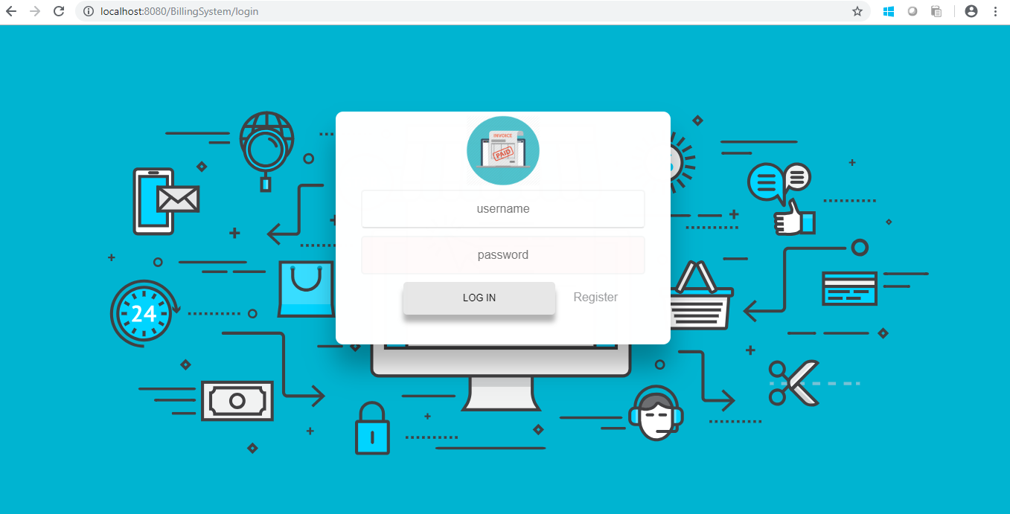
BPS_Pic-2.0 Login page

Vendor Registration

Functional Requirement
This use case deals with the capture of vendor details. The ‘admin’ here shall be the operator of the system and will be keying in the vendor details.

UI Validations
- All fields are mandatory
- Vendor Name ,Company Reg. No. should have maximum length of 50 input characters.
- The Email ID format must be checked.
- Website should be alphanumeric of 15 length.
- Contact Number must be of 12 digits’ length.
- Payment gateway should be alphanumeric of 15 length.
- First Name, Last Name should contain only alphabets.
- Vendor Type, Address, Country, State fields should be chosen from the dropdown options.
- Certificate Issued date, Certificate Validity date, Year of Establishment should be chosen from the dropdown date value.

UI Controls
# | UI Component | Type | Name | Details
1 | Vendor Name | Text Field | VendorName | To enter vendor name of vendor
2 | Company Registration No | Text Field | CompanyRegNo | To enter company registration number of vendor
3 | vendorType | Text Field | VendorType | To enter Type of vendor
4 | address | Text Field | Address | To enter address of vendor
5 | country | Text Field | Country | To enter country of vendor
6 | state | Text Field | State | To enter state of vendor
7 | emailId | Text Field | EmailId | To enter email Id currently used by vendor
8 | contactNo | Text Field | ContactNo | To enter contact number of vendor
9 | website | Text Field | Website | To enter website used by vendor
10 | certificateIssueDate | Date | CertificateIssueDate | To enter certificate Issue Date of vendor
11 | certificateValidityDate | Date | CertificateValidityDate | To enter certificate Validity Date of vendor
12 | yearOfEstablishment | Text Field | YearOfEstablishment | To enter year of Establishment of vendor
13 | paymentGateway | Text Field | PaymentGateway | To enter payment Gateway used by vendor

UI Methods Definition
Method Name | Parameter | Details
Registor_button | Object User | Allows the vendor to register his details
Reset_button | None | Allows the vendor to clear the fields

UI Design

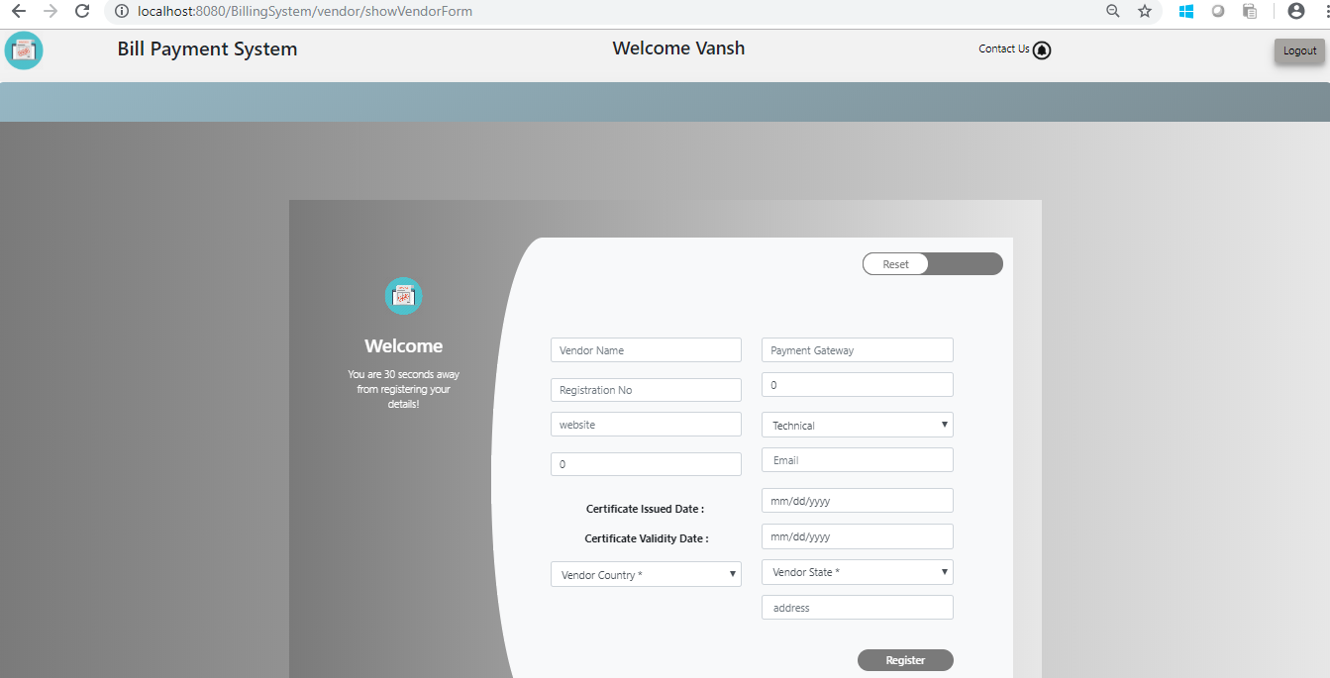
BPS_Pic-5.0 Vendor Registration Form

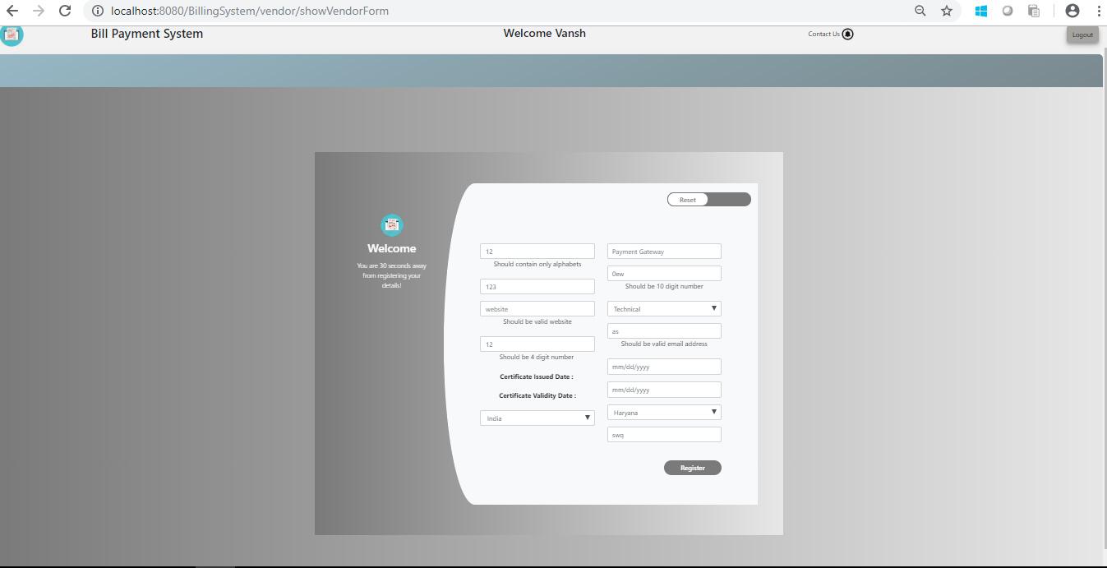
BPS_Pic-15.0 VendorRegistration validation Form

Record Bill

Functional Requirement
This use case deals with the ability to record bill details pertaining to various categories. The ‘user’ here shall be the operator of the system and will be keying in the bill record(registration) details.

UI Validations
- All fields are mandatory.
- PAN Number must be of 15 digits’ length
- Amount to be paid should contain only numeric digits.
- Credit Card Holder name should consist of alphabets only.
- Credit Card CVV field should contain only numerical digits of length 3.
- Credit card Number should be of exactly 12 digits.

UI Methods Definition
Method Name | Parameter | Details
Transaction History | Object User | Allows the user to check all the transactions.
Logout | None | Allows the user to logout
Electricity | Object User | Allows user to display electricity pending bills
Tax | Object User | Allows user to display tax pending bills
Insurance | Object User | Allows user to display insurance pending bills
DTH | Object User | Allows user to display DTH pending bills
Credit Card | Object User | Allows user to display Credit Card pending bills
Others | Object User | Allows user to display others pending bills
Telephone | Object User | Allows user to display telephone pending bills
Loan | Object User | Allows user to display loan pending bills

UI Design
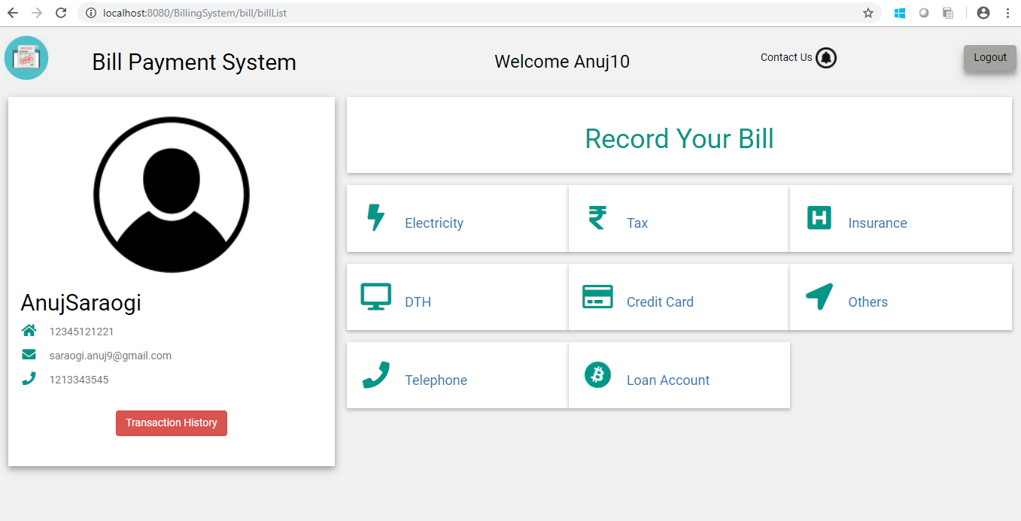BPS_Pic-7.0 Bill Pay Page

Pending Bills

Functional Requirement
This use case deals with the ability of the system to provide information about pending bills for a given user of the given selected type by the user. The ‘user’ here shall be the operator of the system and will be keying in the pending bill details.

UI Methods Definition
Method Name | Parameter | Details
Transaction History | Object User | Allows the user to check all the transactions.
Logout | None | Allows the user to logout
Delete | Object User | Allows user to delete the pending bill
Pay | Object User | Allows user to pay the bill
Back | Object User | Allows user to redirect to Bill Pay page

UI Design
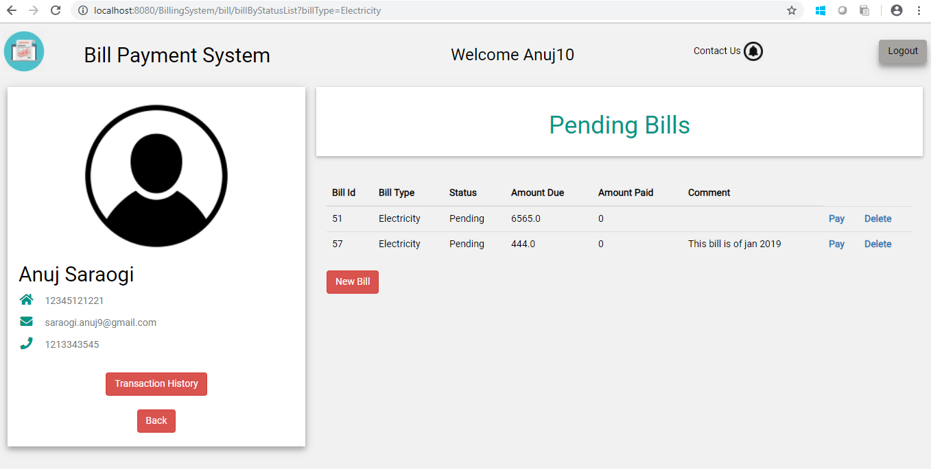
BPS_Pic-8.0 Bill Pending Page

Pay Bills

Functional Requirement
This use case deals with the ability of the user to pay the pending bills listed against it.The ‘user’ here shall be the operator of the system and will be keying in the bill payment details

UI Controls
# | UI Component | Type | Name | Details
1 | Username | Text Field | Username | To enter username of user
2 | Pan | Text Field | Pan | To enter pan card number of user
3. | Amount | Text Field | Amount | To enter amount to be payed
4. | Credit Card Name | Text Field | CreditCardName | To enter credit card name of user
5. | Credit Card CVV | Text Field | CreditCardCVV | To enter credit card CVV number
6. | Credit Card Number | Text Field | CreditCardNumber | To enter credit card digits
7. | Payment Through | Dropdown | PaymentThrough | To choose payment through which user want to pay
8. | Vendor | Dropdown | Vendor | To choose which vendor the user want to pay

UI Methods Definition
Method Name | Parameter | Details
Transaction History | Object User | Allows the user to check all the transactions.
Logout | None | Allows the user to logout
Save and Exit | Object User | Allows user to save the bill as pending
Pay | Object User | Allows user to save the bill as paid
Cancel | Object User | Allows user to reset the details of the bill form
Back | Object User | Allows user to redirect to Bill Pay page

UI Design
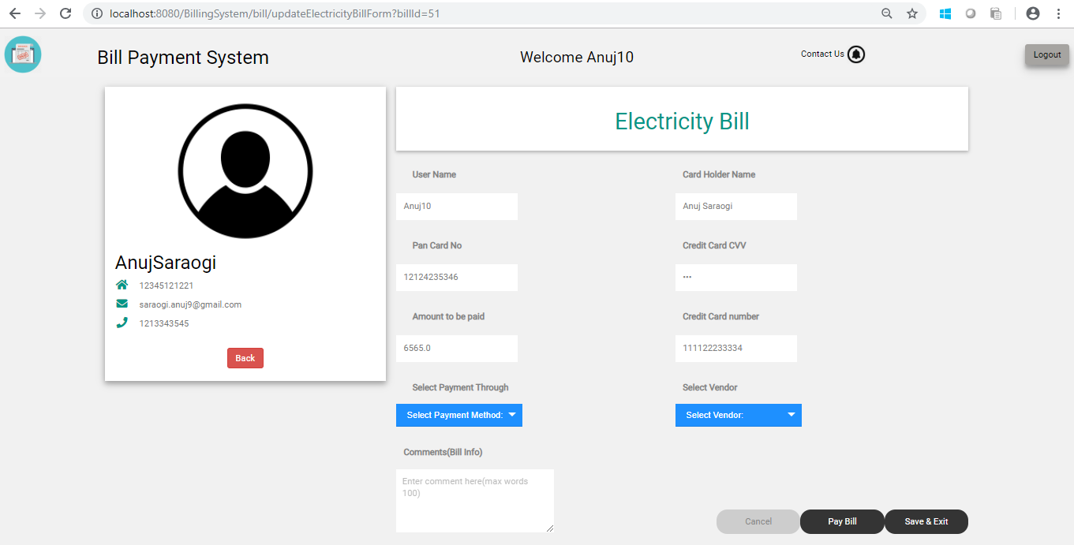
BPS_Pic-9.0 Recorded Bill Form
BPS_Pic-10.0 New Bill Form
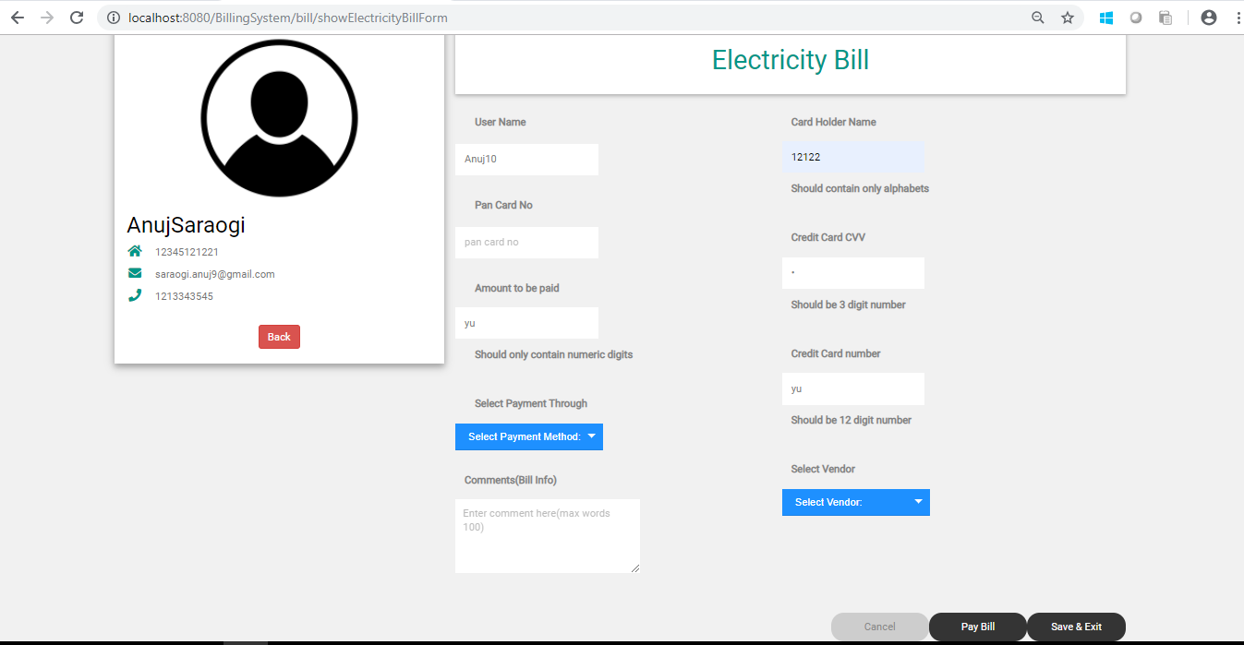
BPS_Pic-16.0 New Bill/Recorded Bill Form Validate

Database Design

Data Model

The following is a schematic view of the database design
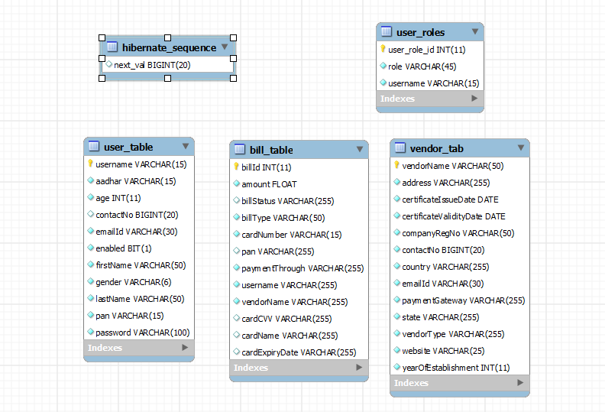
BPS_Pic-13.0 Database Design

Tables Structure
user_table:
Column Name | Data Type | Length | Nulls
firstName | varchar | 50 | N
lastName | varchar | 50 | N
username | varchar | 15 | N
age | int | 2 | N
gender | varchar | 6 | N
pan | varchar | 15 | N
contact_number | varchar | 10 | N
aadhar | varchar | 15 | N
emailId | varchar | 30 | N
password | varchar | 15 | N

vendor_tab:
Column Name | Data Type | Length | Nulls
vendorName | varchar | 50 | N
companyRegNo | varchar | 50 | N
vendorType | varchar | NA | N
address | varchar | NA | N
country | varchar | NA | N
state | varchar | NA | N
emailId | varchar | 30 | N
contactNo | long | 10 | N
website | varchar | NA | N
certificateIssueDate | Date | NA | N
certificateValidityDate | Date | NA | N
yearOfEstablishment | int | NA | N
paymentGateway | varchar | 15 | N

bill_table:
Column Name | Data Type | Length | Nulls
billId | int | 50 | N
amount | float | 10 | N
cardNumber | varchar | 15 | N
billType | varchar | 50 | N
username | varchar | NA | N
pan | varchar | NA | N
vendorName | varchar | NA | N
billStatus | varchar | NA | N
paymentThrough | varchar | NA | N
cardCVV | varchar | NA | N
cardName | varchar | NA | N
cardExpiryDate | varchar | NA | N

Change Log
Please note that this table needs to be maintained even if a Configuration Management tool is used.
Version Number | Changes made
V1.0 | <First version>
V1.1 | <If the change details are not explicitly documented in the table below, reference should be provided here>
V1.1 | Page no | Changed by | Effective date | Changes effected
V1.2 | <If the change details are not explicitly documented in the table below, reference should be provided here>
V1.2 | Page no | Changed by | Effective date | Changes effected

